**JECRC**

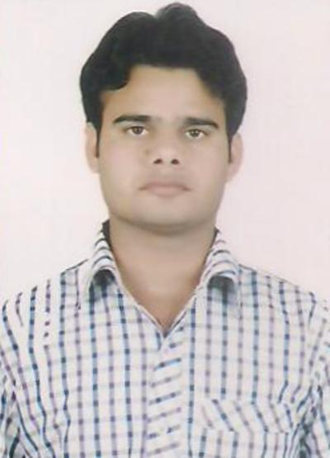

**JAIPUR**

**INDIVIDUAL FACULTY DATA SHEET**

|  |  |  |
| --- | --- | --- |
| **Name of the faculty member** | **:** | Sunil Kumar Sharma |
| **Present Designation** | AP |  |

**Email Id: sunilsharma.ee@jecrc.ac.in**

**Contact Details: 7976447972**

**I. Particulars of Educational Qualification: (*only completed*)**

|  |  |  |  |  |  |
| --- | --- | --- | --- | --- | --- |
| **Category** | **Name of the Degree** | **Specialization** | **Year of Passing** | **Name of the College** | **Name of the University** |
| **UG** | **B.tech** | **Electrical** | **2011** | **Bmit jaipur** | **RTU** |
| **PG** | **M.tech** | **Power system** | **2017** | **Jagannath university** | **Jagannath university** |
| **Ph.D.** |  |  |  |  |  |

**II. Academic Experience : 06 yrs.**

**III. Industrial Experience : 06 months**

**IV. Title of Ph.D. Thesis :**

**V. Awards/Achievements :**

**VI. Research/Specialization : 03**

**VII. Course Taught : El. machine**

**VIII. Refereed International Journal Publication :**

**IX. International Conference Proceeding :**

**X. Books Written :**

**XI. M.Tech Thesis Guide : Ms. Sushma lohia**

**XII. PHD Thesis Guide :**

**XIII. Professional Body Membership :**